Project
Delivering Better Outcomes Together
Location
London Borough of Southwark
Topic
National Trial of a Single Route of Redress

Learning from national trial appeals

Southwark have been working with their social care and health colleagues to implement new ways of working collaboratively on national trial appeals.
Southwark have had 13 national trial appeals since 2018 with an even split between health and social care. Most cases have been resolved by agreement with the SEND team and legal team brokering agreement with other services. Three cases went to hearing where recommendations were made which were not agreed in advance. In one case the recommendations were rejected.
Challenges
The team identified the following areas where improvements could be made:
- Communication
- Receiving accurate information from all parties in relations to provision and costs.
- Understanding different teams’ ways of working and aligning their processes with the tribunal timetable.
- Understanding the legal duties of other pieces of legislation that services have to comply with i.e. Care Act, CSDPA, Continuing Care
- Ensuring social care services and CCG know what the parent is seeking.
- Witnesses
- Ensuring the witness have the appropriate seniority.
- Ensuring they know the child well enough to give relevant evidence.
- Briefing witnesses on tribunal procedure – what to expect and how it differs from other legal proceedings.
- Tribunal recommendations
- Ensuring that other services understand the need to respond to recommendations.
- Making sure this is done in the required time and that enough detail is given.
- Helping services to understand that this is an important part of the national trial proceedings and that their decision can be challenged by the parent or young person.

Solutions
- Southwark held a joint workshop with middle managers in the SEND and social care teams to raise awareness of the national trial and come up with ideas to improve internal processes.
- As a result, they have introduced adapted workflow to include health and social care (see diagram below)
- Relevant officers from the SEND team, social care and health now meet weekly for case management meetings.
Top Tips
- Make sure there are procedures for good communication between teams
- Cultivate a ‘one authority’ approach
- Be clear about what is needed from each service and when its needed
- Communicate early and communicate often

Diagram 1: The adapted workflow that Southwark have developed in partnership with social care and health colleagues:
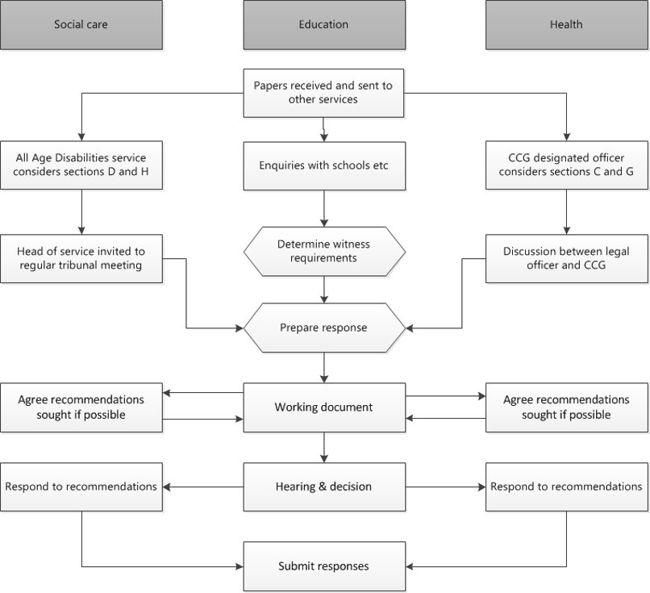

For more information:
Please contact: Yvonne Ely, Assistant Director at Yvonne.Ely@southwark.gov.uk or Dominic Sefton, Education solicitor at Dominic.Sefton@southwark.gov.uk
The information provided in this case study originates from a presentation delivered at the National Trial Briefing Events in March 2021 hosted by Mott MacDonald on behalf of the Department for Education. The full presentation slides can be viewed or download at Event Materials and Resources - Mott MacDonald (sendpathfinder.co.uk).

